武汉纺织大学

面向对象课程设计

**高校人员信息管理系统**

**学 院： 计算机与人工智能学院**

**班 级： 计算机12104班**

**姓 名： 余心武,罗臣**

**学 号： 2104241115,2104241121**

**指导老师： 李敏**

**成 绩：**

**完成日期： 2023年 1月 12日**

目 录

1 需求分析 1

1.1用户登陆 1

1.2主菜单 1

1.3各项功能 1

1.3.1 教师管理 1

1.3.2 实验员管理 2

1.3.3 行政员管理 2

1.3.4 教师兼行政员管理 2

1.3.5 退出 2

2 系统设计 3

2.1 需求分析 3

2.1.1 问题分析................................................................................................................3

2.1.2 功能分析................................................................................................................3

2.2 总体设计和ER图 4

2.2.1 系统流程设计.........................................................................................................5

2.3 数据结构 5

2.3.1 类设计................................................................................................................. 5

2.3.2 函数设计..............................................................................................................8

2.4 设计分析和UML类图（Class Diagram） 27

2.4.1 person类................................................................................................................28

2.4.2 派生类..................................................................................................................28

2.4.3 管理类..................................................................................................................28

2.4.4 添加函数..............................................................................................................28

2.4.5 查询函数..............................................................................................................28

2.4.6 显示函数..............................................................................................................28

2.4.7 编辑函数..............................................................................................................29

2.4.8 删除函数..............................................................................................................29

2.4.9 保存函数..............................................................................................................29

2.4.10读取函数.............................................................................................................29

2.4.11菜单函数.............................................................................................................30

2.4.12 UML类图.............................................................................................................30

3 系统测试和运行结果 31

3.1 登录界面 31

3.2 主界面 32

3.3 操作界面 33

3.4 运行结果 33

4 系统总结 34

# 1 需求分析

### 某高校有四类员工：教师、实验员、行政人员，教师兼行政人员；共有的信息包括：编号、姓名、性别、年龄等。其中，教师还包含的信息有：所在系部、专业、职称；实验员还包含的信息由：所在实验室、职务；行政人员还包含的信息有：政治面貌、职称等。

## 1.1用户登陆

当程序运行时，显示“欢迎使用高校人员管理系统，请输入密码”，提示用户输入密码，当密码不正确时，显示提示信息“密码错误”，退出系统。

## 1.2主菜单

当密码正确时，进入系统主界面，如下：

// 欢迎使用高校人员信息管理系统

1.教师管理

2.实验员管理

3.行政员管理

4.教师兼行政管理

0.退出

// 请选择您要管理的人员:

如果输入0-4以外的选择，则无效，只能输入0-4后，进入下一级菜单

## 1.3各项功能

### 1.3.1 教师管理

当选择1时显示

//教师管理

1.添加

2.查询

3.显示

4.编辑

5.删除

6.统计

7.保存

8.读取

0.退出

//请选择：

### 1.3.2 实验员管理

当选择2时，显示//实验人员管理

1.添加

2.查询

3.显示

4.编辑

5.删除

6.统计

7.保存

8.读取

0.退出

//请选择：

### 1.3.3 行政员管理

当选择3时，显示

//行政人员管理

1.添加

2.查询

3.显示

4.编辑

5.删除

6.统计

7.保存

8.读取

0.退出

//请选择：

### 1.3.4 教师兼行政管理

当选择4时，显示

//教师兼行政管理

1.添加

2.查询

3.显示

4.编辑

5.删除

6.统计

7.保存

8.读取

0.退出

//请选择：

### 1.3.5 退出

输入0时显示谢谢使用并退出

# 2 系统设计

## 2.1 需求分析

## 2.1.1 问题分析

根据高校人员管理系统要求，设计一个高校人员的抽象person类，包括以下数据成员：

1.编号—num 2.姓名—name

3.性别—sex 3.年龄—age

## 2.1.2 功能分析

根据需求，该系统应包括以下这些功能

1. 添加功能—int Add();
2. 查找功能—int Search();
3. 显示功能—void Show();
4. 编辑功能—void Edit();
5. 删除功能—int Delete();
6. 保存功能—void Save();
7. 读取功能—void Read();
8. 主函数—输出菜单，功能选择，退出系统

## 2.2 总体设计和ER图

### 根据要求，系统流程图如下所示：Q7ED{S[CCZUTYJ}T)MDS$JC

%3CmxGraphModel%3E%3Croot%3E%3CmxCell%20id%3D%220%22%2F%3E%3CmxCell%20id%3D%221%22%20parent%3D%220%22%2F%3E%3Cmysql.table%20entity.table.tableName%3D%22uses%22%20label%3D%22uses%22%20id%3D%222%22%3E%3CmxCell%20style%3D%22swimlane%3BfontStyle%3D0%3BchildLayout%3DstackLayout%3Bhorizontal%3D1%3Bhtml%3D1%3BstartSize%3D26%3BfillColor%3D%23b0e3e6%3BhorizontalStack%3D0%3BresizeParent%3D1%3BresizeParentMax%3D0%3BresizeLast%3D0%3Bcollapsible%3D1%3BmarginBottom%3D0%3BswimlaneFillColor%3D%23ffffff%3Balign%3Dcenter%3BfontSize%3D13%3BstrokeColor%3D%230e8088%3Brounded%3D0%3Bshadow%3D1%3Bcomic%3D0%3Bglass%3D0%3BgradientDirection%3Dsouth%3BgradientColor%3D%23ffffff%3B%22%20vertex%3D%221%22%20connectable%3D%220%22%20parent%3D%221%22%3E%3CmxGeometry%20x%3D%2260%22%20y%3D%2250%22%20width%3D%22310%22%20height%3D%22130%22%20as%3D%22geometry%22%2F%3E%3C%2FmxCell%3E%3C%2Fmysql.table%3E%3Cmysql.column%20entity.column.tableName%3D%22uses%22%20entity.column.name%3D%22userName%22%20entity.column.dataType%3D%22VARCHAR%22%20entity.column.PK%3D%22true%22%20label%3D%22%26lt%3Bimg%20title%3D%26quot%3BPrimary%20Key%26quot%3B%20src%3D%26quot%3Bimg%2Fdb%2Fkey1.png%26quot%3B%20width%3D%26quot%3B16%26quot%3B%20height%3D%26quot%3B16%26quot%3B%20align%3D%26quot%3Btop%26quot%3B%26gt%3B%26amp%3Bnbsp%3B%26lt%3Bfont%20size%3D%26quot%3B1%26quot%3B%20face%3D%26quot%3BTahoma%26quot%3B%26gt%3B%26lt%3Bspan%20style%3D%26quot%3Bfont-size%3A%2013px%26quot%3B%26gt%3B%26lt%3Bb%26gt%3Bid%20int%20primary%20key%26lt%3B%2Fb%26gt%3B%26lt%3B%2Fspan%26gt%3B%26lt%3B%2Ffont%26gt%3B%22%20entity.column.oldName%3D%22id%22%20entity.column.datalen%3D%2220%22%20entity.column.decimals%3D%22%22%20entity.column.autoIncreament%3D%22%22%20entity.column.unsigned%3D%22%22%20entity.column.bin%3D%22%22%20entity.column.ascii%3D%22%22%20entity.column.unicode%3D%22%22%20entity.column.unique%3D%22%22%20entity.column.isNotNull%3D%22NOT%20NULL%22%20entity.column.defaultValue%3D%22%22%20entity.column.comment%3D%22%22%20entity.column.enum%3D%22%22%20entity.column.set%3D%22%22%20entity.column.enumSetValue%3D%22%22%20id%3D%223%22%3E%3CmxCell%20style%3D%22text%3Bhtml%3D1%3BstrokeColor%3Dnone%3BfillColor%3Dnone%3BspacingLeft%3D4%3BspacingRight%3D4%3Boverflow%3Dhidden%3Brotatable%3D0%3BportConstraint%3Deastwest%3BfontSize%3D12%3BverticalAlign%3Dmiddle%3B%22%20vertex%3D%221%22%20parent%3D%222%22%3E%3CmxGeometry%20y%3D%2226%22%20width%3D%22310%22%20height%3D%2226%22%20as%3D%22geometry%22%2F%3E%3C%2FmxCell%3E%3C%2Fmysql.column%3E%3Cmysql.column%20entity.column.tableName%3D%22uses%22%20entity.column.name%3D%22chrName%22%20entity.column.datalen%3D%2220%22%20entity.column.dataType%3D%22VARCHAR%22%20label%3D%22%26lt%3Bimg%20title%3D%26quot%3BPrimary%20Key%26quot%3B%20src%3D%26quot%3Bimages%2Fspacer.gif%26quot%3B%20width%3D%26quot%3B16%26quot%3B%20height%3D%26quot%3B16%26quot%3B%20align%3D%26quot%3Btop%26quot%3B%26gt%3B%26amp%3Bnbsp%3B%26lt%3Bfont%20size%3D%26quot%3B1%26quot%3B%20face%3D%26quot%3BTahoma%26quot%3B%26gt%3B%26lt%3Bspan%20style%3D%26quot%3Bfont-size%3A%2013px%26quot%3B%26gt%3B%26lt%3Bb%26gt%3Bname%20varchar(10)%26lt%3B%2Fb%26gt%3B%26lt%3B%2Fspan%26gt%3B%26lt%3B%2Ffont%26gt%3B%22%20entity.column.oldName%3D%22name%22%20entity.column.decimals%3D%22%22%20entity.column.autoIncreament%3D%22%22%20entity.column.unsigned%3D%22%22%20entity.column.bin%3D%22%22%20entity.column.ascii%3D%22%22%20entity.column.unicode%3D%22%22%20entity.column.PK%3D%22false%22%20entity.column.unique%3D%22%22%20entity.column.isNotNull%3D%22%22%20entity.column.defaultValue%3D%22%22%20entity.column.comment%3D%22%22%20entity.column.enum%3D%22%22%20entity.column.set%3D%22%22%20entity.column.enumSetValue%3D%22%22%20id%3D%224%22%3E%3CmxCell%20style%3D%22text%3Bhtml%3D1%3BstrokeColor%3Dnone%3BfillColor%3Dnone%3BspacingLeft%3D4%3BspacingRight%3D4%3Boverflow%3Dhidden%3Brotatable%3D0%3BportConstraint%3Deastwest%3BfontSize%3D12%3BverticalAlign%3Dmiddle%3B%22%20vertex%3D%221%22%20parent%3D%222%22%3E%3CmxGeometry%20y%3D%2252%22%20width%3D%22310%22%20height%3D%2226%22%20as%3D%22geometry%22%2F%3E%3C%2FmxCell%3E%3C%2Fmysql.column%3E%3Cmysql.column%20entity.column.tableName%3D%22uses%22%20entity.column.name%3D%22password%22%20entity.column.datalen%3D%2250%22%20entity.column.dataType%3D%22VARCHAR%22%20label%3D%22%26lt%3Bimg%20title%3D%26quot%3BPrimary%20Key%26quot%3B%20src%3D%26quot%3Bimages%2Fspacer.gif%26quot%3B%20width%3D%26quot%3B16%26quot%3B%20height%3D%26quot%3B16%26quot%3B%20align%3D%26quot%3Btop%26quot%3B%26gt%3B%26amp%3Bnbsp%3B%26lt%3Bfont%20size%3D%26quot%3B1%26quot%3B%20face%3D%26quot%3BTahoma%26quot%3B%26gt%3B%26lt%3Bspan%20style%3D%26quot%3Bfont-size%3A%2013px%26quot%3B%26gt%3B%26lt%3Bb%26gt%3Bname%20varchar(10)%26lt%3B%2Fb%26gt%3B%26lt%3B%2Fspan%26gt%3B%26lt%3B%2Ffont%26gt%3B%22%20entity.column.oldName%3D%22chrName%22%20entity.column.decimals%3D%22%22%20entity.column.autoIncreament%3D%22%22%20entity.column.unsigned%3D%22%22%20entity.column.bin%3D%22%22%20entity.column.ascii%3D%22%22%20entity.column.unicode%3D%22%22%20entity.column.PK%3D%22false%22%20entity.column.unique%3D%22%22%20entity.column.isNotNull%3D%22%22%20entity.column.defaultValue%3D%22%22%20entity.column.comment%3D%22%E5%AF%86%E7%A0%81%22%20entity.column.enum%3D%22%22%20entity.column.set%3D%22%22%20entity.column.enumSetValue%3D%22%22%20id%3D%225%22%3E%3CmxCell%20style%3D%22text%3Bhtml%3D1%3BstrokeColor%3Dnone%3BfillColor%3Dnone%3BspacingLeft%3D4%3BspacingRight%3D4%3Boverflow%3Dhidden%3Brotatable%3D0%3BportConstraint%3Deastwest%3BfontSize%3D12%3BverticalAlign%3Dmiddle%3B%22%20vertex%3D%221%22%20parent%3D%222%22%3E%3CmxGeometry%20y%3D%2278%22%20width%3D%22310%22%20height%3D%2226%22%20as%3D%22geometry%22%2F%3E%3C%2FmxCell%3E%3C%2Fmysql.column%3E%3Cmysql.column%20entity.column.tableName%3D%22uses%22%20entity.column.name%3D%22role%22%20entity.column.datalen%3D%2220%22%20entity.column.dataType%3D%22VARCHAR%22%20label%3D%22%26lt%3Bimg%20title%3D%26quot%3BPrimary%20Key%26quot%3B%20src%3D%26quot%3Bimages%2Fspacer.gif%26quot%3B%20width%3D%26quot%3B16%26quot%3B%20height%3D%26quot%3B16%26quot%3B%20align%3D%26quot%3Btop%26quot%3B%26gt%3B%26amp%3Bnbsp%3B%26lt%3Bfont%20size%3D%26quot%3B1%26quot%3B%20face%3D%26quot%3BTahoma%26quot%3B%26gt%3B%26lt%3Bspan%20style%3D%26quot%3Bfont-size%3A%2013px%26quot%3B%26gt%3B%26lt%3Bb%26gt%3Bname%20varchar(10)%26lt%3B%2Fb%26gt%3B%26lt%3B%2Fspan%26gt%3B%26lt%3B%2Ffont%26gt%3B%22%20entity.column.oldName%3D%22chrName%22%20entity.column.decimals%3D%22%22%20entity.column.autoIncreament%3D%22%22%20entity.column.unsigned%3D%22%22%20entity.column.bin%3D%22%22%20entity.column.ascii%3D%22%22%20entity.column.unicode%3D%22%22%20entity.column.PK%3D%22false%22%20entity.column.unique%3D%22%22%20entity.column.isNotNull%3D%22%22%20entity.column.defaultValue%3D%22%22%20entity.column.comment%3D%22%E8%A7%92%E8%89%B2%22%20entity.column.enum%3D%22%22%20entity.column.set%3D%22%22%20entity.column.enumSetValue%3D%22%22%20id%3D%226%22%3E%3CmxCell%20style%3D%22text%3Bhtml%3D1%3BstrokeColor%3Dnone%3BfillColor%3Dnone%3BspacingLeft%3D4%3BspacingRight%3D4%3Boverflow%3Dhidden%3Brotatable%3D0%3BportConstraint%3Deastwest%3BfontSize%3D12%3BverticalAlign%3Dmiddle%3B%22%20vertex%3D%221%22%20parent%3D%222%22%3E%3CmxGeometry%20y%3D%22104%22%20width%3D%22310%22%20height%3D%2226%22%20as%3D%22geometry%22%2F%3E%3C%2FmxCell%3E%3C%2Fmysql.column%3E%3Cmysql.table%20entity.table.tableName%3D%22product%22%20label%3D%22product%22%20id%3D%227%22%3E%3CmxCell%20style%3D%22swimlane%3BfontStyle%3D0%3BchildLayout%3DstackLayout%3Bhorizontal%3D1%3Bhtml%3D1%3BstartSize%3D26%3BfillColor%3D%23b0e3e6%3BhorizontalStack%3D0%3BresizeParent%3D1%3BresizeParentMax%3D0%3BresizeLast%3D0%3Bcollapsible%3D1%3BmarginBottom%3D0%3BswimlaneFillColor%3D%23ffffff%3Balign%3Dcenter%3BfontSize%3D13%3BstrokeColor%3D%230e8088%3Brounded%3D0%3Bshadow%3D1%3Bcomic%3D0%3Bglass%3D0%3BgradientDirection%3Dsouth%3BgradientColor%3D%23ffffff%3B%22%20vertex%3D%221%22%20connectable%3D%220%22%20parent%3D%221%22%3E%3CmxGeometry%20x%3D%2260%22%20y%3D%22210%22%20width%3D%22310%22%20height%3D%22130%22%20as%3D%22geometry%22%2F%3E%3C%2FmxCell%3E%3C%2Fmysql.table%3E%3Cmysql.column%20entity.column.tableName%3D%22product%22%20entity.column.name%3D%22barcode%22%20entity.column.dataType%3D%22VARCHAR%22%20entity.column.PK%3D%22true%22%20label%3D%22%26lt%3Bimg%20title%3D%26quot%3BPrimary%20Key%26quot%3B%20src%3D%26quot%3Bimg%2Fdb%2Fkey1.png%26quot%3B%20width%3D%26quot%3B16%26quot%3B%20height%3D%26quot%3B16%26quot%3B%20align%3D%26quot%3Btop%26quot%3B%26gt%3B%26amp%3Bnbsp%3B%26lt%3Bfont%20size%3D%26quot%3B1%26quot%3B%20face%3D%26quot%3BTahoma%26quot%3B%26gt%3B%26lt%3Bspan%20style%3D%26quot%3Bfont-size%3A%2013px%26quot%3B%26gt%3B%26lt%3Bb%26gt%3Bid%20int%20primary%20key%26lt%3B%2Fb%26gt%3B%26lt%3B%2Fspan%26gt%3B%26lt%3B%2Ffont%26gt%3B%22%20entity.column.oldName%3D%22id%22%20entity.column.datalen%3D%2210%22%20entity.column.decimals%3D%22%22%20entity.column.autoIncreament%3D%22%22%20entity.column.unsigned%3D%22%22%20entity.column.bin%3D%22%22%20entity.column.ascii%3D%22%22%20entity.column.unicode%3D%22%22%20entity.column.unique%3D%22%22%20entity.column.isNotNull%3D%22NOT%20NULL%22%20entity.column.defaultValue%3D%22%22%20entity.column.comment%3D%22%22%20entity.column.enum%3D%22%22%20entity.column.set%3D%22%22%20entity.column.enumSetValue%3D%22%22%20id%3D%228%22%3E%3CmxCell%20style%3D%22text%3Bhtml%3D1%3BstrokeColor%3Dnone%3BfillColor%3Dnone%3BspacingLeft%3D4%3BspacingRight%3D4%3Boverflow%3Dhidden%3Brotatable%3D0%3BportConstraint%3Deastwest%3BfontSize%3D12%3BverticalAlign%3Dmiddle%3B%22%20vertex%3D%221%22%20parent%3D%227%22%3E%3CmxGeometry%20y%3D%2226%22%20width%3D%22310%22%20height%3D%2226%22%20as%3D%22geometry%22%2F%3E%3C%2FmxCell%3E%3C%2Fmysql.column%3E%3Cmysql.column%20entity.column.tableName%3D%22product%22%20entity.column.name%3D%22productName%22%20entity.column.datalen%3D%2250%22%20entity.column.dataType%3D%22VARCHAR%22%20label%3D%22%26lt%3Bimg%20title%3D%26quot%3BPrimary%20Key%26quot%3B%20src%3D%26quot%3Bimages%2Fspacer.gif%26quot%3B%20width%3D%26quot%3B16%26quot%3B%20height%3D%26quot%3B16%26quot%3B%20align%3D%26quot%3Btop%26quot%3B%26gt%3B%26amp%3Bnbsp%3B%26lt%3Bfont%20size%3D%26quot%3B1%26quot%3B%20face%3D%26quot%3BTahoma%26quot%3B%26gt%3B%26lt%3Bspan%20style%3D%26quot%3Bfont-size%3A%2013px%26quot%3B%26gt%3B%26lt%3Bb%26gt%3Bname%20varchar(10)%26lt%3B%2Fb%26gt%3B%26lt%3B%2Fspan%26gt%3B%26lt%3B%2Ffont%26gt%3B%22%20entity.column.oldName%3D%22name%22%20entity.column.decimals%3D%22%22%20entity.column.autoIncreament%3D%22%22%20entity.column.unsigned%3D%22%22%20entity.column.bin%3D%22%22%20entity.column.ascii%3D%22%22%20entity.column.unicode%3D%22%22%20entity.column.PK%3D%22false%22%20entity.column.unique%3D%22%22%20entity.column.isNotNull%3D%22%22%20entity.column.defaultValue%3D%22%22%20entity.column.comment%3D%22%22%20entity.column.enum%3D%22%22%20entity.column.set%3D%22%22%20entity.column.enumSetValue%3D%22%22%20id%3D%229%22%3E%3CmxCell%20style%3D%22text%3Bhtml%3D1%3BstrokeColor%3Dnone%3BfillColor%3Dnone%3BspacingLeft%3D4%3BspacingRight%3D4%3Boverflow%3Dhidden%3Brotatable%3D0%3BportConstraint%3Deastwest%3BfontSize%3D12%3BverticalAlign%3Dmiddle%3B%22%20vertex%3D%221%22%20parent%3D%227%22%3E%3CmxGeometry%20y%3D%2252%22%20width%3D%22310%22%20height%3D%2226%22%20as%3D%22geometry%22%2F%3E%3C%2FmxCell%3E%3C%2Fmysql.column%3E%3Cmysql.column%20entity.column.tableName%3D%22product%22%20entity.column.name%3D%22price%22%20entity.column.datalen%3D%229%22%20entity.column.dataType%3D%22DECIMAL%22%20label%3D%22%26lt%3Bimg%20title%3D%26quot%3BPrimary%20Key%26quot%3B%20src%3D%26quot%3Bimages%2Fspacer.gif%26quot%3B%20width%3D%26quot%3B16%26quot%3B%20height%3D%26quot%3B16%26quot%3B%20align%3D%26quot%3Btop%26quot%3B%26gt%3B%26amp%3Bnbsp%3B%26lt%3Bfont%20size%3D%26quot%3B1%26quot%3B%20face%3D%26quot%3BTahoma%26quot%3B%26gt%3B%26lt%3Bspan%20style%3D%26quot%3Bfont-size%3A%2013px%26quot%3B%26gt%3B%26lt%3Bb%26gt%3Bname%20varchar(10)%26lt%3B%2Fb%26gt%3B%26lt%3B%2Fspan%26gt%3B%26lt%3B%2Ffont%26gt%3B%22%20entity.column.oldName%3D%22price%22%20entity.column.decimals%3D%222%22%20entity.column.autoIncreament%3D%22%22%20entity.column.unsigned%3D%22%22%20entity.column.bin%3D%22%22%20entity.column.ascii%3D%22%22%20entity.column.unicode%3D%22%22%20entity.column.PK%3D%22false%22%20entity.column.unique%3D%22%22%20entity.column.isNotNull%3D%22%22%20entity.column.defaultValue%3D%22%22%20entity.column.comment%3D%22%22%20entity.column.enum%3D%22%22%20entity.column.set%3D%22%22%20entity.column.enumSetValue%3D%22%22%20id%3D%2210%22%3E%3CmxCell%20style%3D%22text%3Bhtml%3D1%3BstrokeColor%3Dnone%3BfillColor%3Dnone%3BspacingLeft%3D4%3BspacingRight%3D4%3Boverflow%3Dhidden%3Brotatable%3D0%3BportConstraint%3Deastwest%3BfontSize%3D12%3BverticalAlign%3Dmiddle%3B%22%20vertex%3D%221%22%20parent%3D%227%22%3E%3CmxGeometry%20y%3D%2278%22%20width%3D%22310%22%20height%3D%2226%22%20as%3D%22geometry%22%2F%3E%3C%2FmxCell%3E%3C%2Fmysql.column%3E%3Cmysql.column%20entity.column.tableName%3D%22product%22%20entity.column.name%3D%22supply%22%20entity.column.datalen%3D%2220%22%20entity.column.dataType%3D%22VARCHAR%22%20label%3D%22%26lt%3Bimg%20title%3D%26quot%3BPrimary%20Key%26quot%3B%20src%3D%26quot%3Bimages%2Fspacer.gif%26quot%3B%20width%3D%26quot%3B16%26quot%3B%20height%3D%26quot%3B16%26quot%3B%20align%3D%26quot%3Btop%26quot%3B%26gt%3B%26amp%3Bnbsp%3B%26lt%3Bfont%20size%3D%26quot%3B1%26quot%3B%20face%3D%26quot%3BTahoma%26quot%3B%26gt%3B%26lt%3Bspan%20style%3D%26quot%3Bfont-size%3A%2013px%26quot%3B%26gt%3B%26lt%3Bb%26gt%3Bname%20varchar(10)%26lt%3B%2Fb%26gt%3B%26lt%3B%2Fspan%26gt%3B%26lt%3B%2Ffont%26gt%3B%22%20entity.column.oldName%3D%22price%22%20entity.column.decimals%3D%22%22%20entity.column.autoIncreament%3D%22%22%20entity.column.unsigned%3D%22%22%20entity.column.bin%3D%22%22%20entity.column.ascii%3D%22%22%20entity.column.unicode%3D%22%22%20entity.column.PK%3D%22false%22%20entity.column.unique%3D%22%22%20entity.column.isNotNull%3D%22%22%20entity.column.defaultValue%3D%22%22%20entity.column.comment%3D%22%22%20entity.column.enum%3D%22%22%20entity.column.set%3D%22%22%20entity.column.enumSetValue%3D%22%22%20id%3D%2211%22%3E%3CmxCell%20style%3D%22text%3Bhtml%3D1%3BstrokeColor%3Dnone%3BfillColor%3Dnone%3BspacingLeft%3D4%3BspacingRight%3D4%3Boverflow%3Dhidden%3Brotatable%3D0%3BportConstraint%3Deastwest%3BfontSize%3D12%3BverticalAlign%3Dmiddle%3B%22%20vertex%3D%221%22%20parent%3D%227%22%3E%3CmxGeometry%20y%3D%22104%22%20width%3D%22310%22%20height%3D%2226%22%20as%3D%22geometry%22%2F%3E%3C%2FmxCell%3E%3C%2Fmysql.column%3E%3Cmysql.table%20entity.table.tableName%3D%22saleDetail%22%20label%3D%22saleDetail%22%20id%3D%2212%22%3E%3CmxCell%20style%3D%22swimlane%3BfontStyle%3D0%3BchildLayout%3DstackLayout%3Bhorizontal%3D1%3Bhtml%3D1%3BstartSize%3D26%3BfillColor%3D%23b0e3e6%3BhorizontalStack%3D0%3BresizeParent%3D1%3BresizeParentMax%3D0%3BresizeLast%3D0%3Bcollapsible%3D1%3BmarginBottom%3D0%3BswimlaneFillColor%3D%23ffffff%3Balign%3Dcenter%3BfontSize%3D13%3BstrokeColor%3D%230e8088%3Brounded%3D0%3Bshadow%3D1%3Bcomic%3D0%3Bglass%3D0%3BgradientDirection%3Dsouth%3BgradientColor%3D%23ffffff%3B%22%20vertex%3D%221%22%20connectable%3D%220%22%20parent%3D%221%22%3E%3CmxGeometry%20x%3D%22480%22%20y%3D%2280%22%20width%3D%22280%22%20height%3D%22208%22%20as%3D%22geometry%22%2F%3E%3C%2FmxCell%3E%3C%2Fmysql.table%3E%3Cmysql.column%20entity.column.tableName%3D%22saleDetail%22%20entity.column.name%3D%22lsh%22%20entity.column.dataType%3D%22VARCHAR%22%20entity.column.PK%3D%22true%22%20label%3D%22%26lt%3Bimg%20title%3D%26quot%3BPrimary%20Key%26quot%3B%20src%3D%26quot%3Bimg%2Fdb%2Fkey1.png%26quot%3B%20width%3D%26quot%3B16%26quot%3B%20height%3D%26quot%3B16%26quot%3B%20align%3D%26quot%3Btop%26quot%3B%26gt%3B%26amp%3Bnbsp%3B%26lt%3Bfont%20size%3D%26quot%3B1%26quot%3B%20face%3D%26quot%3BTahoma%26quot%3B%26gt%3B%26lt%3Bspan%20style%3D%26quot%3Bfont-size%3A%2013px%26quot%3B%26gt%3B%26lt%3Bb%26gt%3Bid%20int%20primary%20key%26lt%3B%2Fb%26gt%3B%26lt%3B%2Fspan%26gt%3B%26lt%3B%2Ffont%26gt%3B%22%20entity.column.oldName%3D%22id%22%20entity.column.datalen%3D%2220%22%20entity.column.decimals%3D%22%22%20entity.column.autoIncreament%3D%22%22%20entity.column.unsigned%3D%22%22%20entity.column.bin%3D%22%22%20entity.column.ascii%3D%22%22%20entity.column.unicode%3D%22%22%20entity.column.unique%3D%22%22%20entity.column.isNotNull%3D%22NOT%20NULL%22%20entity.column.defaultValue%3D%22%22%20entity.column.comment%3D%22%22%20entity.column.enum%3D%22%22%20entity.column.set%3D%22%22%20entity.column.enumSetValue%3D%22%22%20id%3D%2213%22%3E%3CmxCell%20style%3D%22text%3Bhtml%3D1%3BstrokeColor%3Dnone%3BfillColor%3Dnone%3BspacingLeft%3D4%3BspacingRight%3D4%3Boverflow%3Dhidden%3Brotatable%3D0%3BportConstraint%3Deastwest%3BfontSize%3D12%3BverticalAlign%3Dmiddle%3B%22%20vertex%3D%221%22%20parent%3D%2212%22%3E%3CmxGeometry%20y%3D%2226%22%20width%3D%22280%22%20height%3D%2226%22%20as%3D%22geometry%22%2F%3E%3C%2FmxCell%3E%3C%2Fmysql.column%3E%3Cmysql.column%20entity.column.tableName%3D%22saleDetail%22%20entity.column.name%3D%22barcode%22%20entity.column.datalen%3D%2210%22%20entity.column.dataType%3D%22VARCHAR%22%20label%3D%22%26lt%3Bimg%20title%3D%26quot%3BPrimary%20Key%26quot%3B%20src%3D%26quot%3Bimages%2Fspacer.gif%26quot%3B%20width%3D%26quot%3B16%26quot%3B%20height%3D%26quot%3B16%26quot%3B%20align%3D%26quot%3Btop%26quot%3B%26gt%3B%26amp%3Bnbsp%3B%26lt%3Bfont%20size%3D%26quot%3B1%26quot%3B%20face%3D%26quot%3BTahoma%26quot%3B%26gt%3B%26lt%3Bspan%20style%3D%26quot%3Bfont-size%3A%2013px%26quot%3B%26gt%3B%26lt%3Bb%26gt%3Bname%20varchar(10)%26lt%3B%2Fb%26gt%3B%26lt%3B%2Fspan%26gt%3B%26lt%3B%2Ffont%26gt%3B%22%20entity.column.oldName%3D%22barcode%22%20entity.column.decimals%3D%22%22%20entity.column.autoIncreament%3D%22%22%20entity.column.unsigned%3D%22%22%20entity.column.bin%3D%22%22%20entity.column.ascii%3D%22%22%20entity.column.unicode%3D%22%22%20entity.column.PK%3D%22false%22%20entity.column.unique%3D%22%22%20entity.column.isNotNull%3D%22%22%20entity.column.defaultValue%3D%22%22%20entity.column.comment%3D%22%22%20entity.column.enum%3D%22%22%20entity.column.set%3D%22%22%20entity.column.enumSetValue%3D%22%22%20id%3D%2214%22%3E%3CmxCell%20style%3D%22text%3Bhtml%3D1%3BstrokeColor%3Dnone%3BfillColor%3Dnone%3BspacingLeft%3D4%3BspacingRight%3D4%3Boverflow%3Dhidden%3Brotatable%3D0%3BportConstraint%3Deastwest%3BfontSize%3D12%3BverticalAlign%3Dmiddle%3B%22%20vertex%3D%221%22%20parent%3D%2212%22%3E%3CmxGeometry%20y%3D%2252%22%20width%3D%22280%22%20height%3D%2226%22%20as%3D%22geometry%22%2F%3E%3C%2FmxCell%3E%3C%2Fmysql.column%3E%3Cmysql.column%20entity.column.tableName%3D%22saleDetail%22%20entity.column.name%3D%22productName%22%20entity.column.datalen%3D%2250%22%20entity.column.dataType%3D%22VARCHAR%22%20label%3D%22%26lt%3Bimg%20title%3D%26quot%3BPrimary%20Key%26quot%3B%20src%3D%26quot%3Bimages%2Fspacer.gif%26quot%3B%20width%3D%26quot%3B16%26quot%3B%20height%3D%26quot%3B16%26quot%3B%20align%3D%26quot%3Btop%26quot%3B%26gt%3B%26amp%3Bnbsp%3B%26lt%3Bfont%20size%3D%26quot%3B1%26quot%3B%20face%3D%26quot%3BTahoma%26quot%3B%26gt%3B%26lt%3Bspan%20style%3D%26quot%3Bfont-size%3A%2013px%26quot%3B%26gt%3B%26lt%3Bb%26gt%3Bname%20varchar(10)%26lt%3B%2Fb%26gt%3B%26lt%3B%2Fspan%26gt%3B%26lt%3B%2Ffont%26gt%3B%22%20entity.column.oldName%3D%22productName%22%20entity.column.decimals%3D%22%22%20entity.column.autoIncreament%3D%22%22%20entity.column.unsigned%3D%22%22%20entity.column.bin%3D%22%22%20entity.column.ascii%3D%22%22%20entity.column.unicode%3D%22%22%20entity.column.PK%3D%22false%22%20entity.column.unique%3D%22%22%20entity.column.isNotNull%3D%22%22%20entity.column.defaultValue%3D%22%22%20entity.column.comment%3D%22%22%20entity.column.enum%3D%22%22%20entity.column.set%3D%22%22%20entity.column.enumSetValue%3D%22%22%20id%3D%2215%22%3E%3CmxCell%20style%3D%22text%3Bhtml%3D1%3BstrokeColor%3Dnone%3BfillColor%3Dnone%3BspacingLeft%3D4%3BspacingRight%3D4%3Boverflow%3Dhidden%3Brotatable%3D0%3BportConstraint%3Deastwest%3BfontSize%3D12%3BverticalAlign%3Dmiddle%3B%22%20vertex%3D%221%22%20parent%3D%2212%22%3E%3CmxGeometry%20y%3D%2278%22%20width%3D%22280%22%20height%3D%2226%22%20as%3D%22geometry%22%2F%3E%3C%2FmxCell%3E%3C%2Fmysql.column%3E%3Cmysql.column%20entity.column.tableName%3D%22saleDetail%22%20entity.column.name%3D%22price%22%20entity.column.datalen%3D%229%22%20entity.column.dataType%3D%22DECIMAL%22%20label%3D%22%26lt%3Bimg%20title%3D%26quot%3BPrimary%20Key%26quot%3B%20src%3D%26quot%3Bimages%2Fspacer.gif%26quot%3B%20width%3D%26quot%3B16%26quot%3B%20height%3D%26quot%3B16%26quot%3B%20align%3D%26quot%3Btop%26quot%3B%26gt%3B%26amp%3Bnbsp%3B%26lt%3Bfont%20size%3D%26quot%3B1%26quot%3B%20face%3D%26quot%3BTahoma%26quot%3B%26gt%3B%26lt%3Bspan%20style%3D%26quot%3Bfont-size%3A%2013px%26quot%3B%26gt%3B%26lt%3Bb%26gt%3Bname%20varchar(10)%26lt%3B%2Fb%26gt%3B%26lt%3B%2Fspan%26gt%3B%26lt%3B%2Ffont%26gt%3B%22%20entity.column.oldName%3D%22productName%22%20entity.column.decimals%3D%222%22%20entity.column.autoIncreament%3D%22%22%20entity.column.unsigned%3D%22%22%20entity.column.bin%3D%22%22%20entity.column.ascii%3D%22%22%20entity.column.unicode%3D%22%22%20entity.column.PK%3D%22false%22%20entity.column.unique%3D%22%22%20entity.column.isNotNull%3D%22%22%20entity.column.defaultValue%3D%22%22%20entity.column.comment%3D%22%22%20entity.column.enum%3D%22%22%20entity.column.set%3D%22%22%20entity.column.enumSetValue%3D%22%22%20id%3D%2216%22%3E%3CmxCell%20style%3D%22text%3Bhtml%3D1%3BstrokeColor%3Dnone%3BfillColor%3Dnone%3BspacingLeft%3D4%3BspacingRight%3D4%3Boverflow%3Dhidden%3Brotatable%3D0%3BportConstraint%3Deastwest%3BfontSize%3D12%3BverticalAlign%3Dmiddle%3B%22%20vertex%3D%221%22%20parent%3D%2212%22%3E%3CmxGeometry%20y%3D%22104%22%20width%3D%22280%22%20height%3D%2226%22%20as%3D%22geometry%22%2F%3E%3C%2FmxCell%3E%3C%2Fmysql.column%3E%3Cmysql.column%20entity.column.tableName%3D%22saleDetail%22%20entity.column.name%3D%22count%22%20entity.column.datalen%3D%229%22%20entity.column.dataType%3D%22INT%22%20label%3D%22%26lt%3Bimg%20title%3D%26quot%3BPrimary%20Key%26quot%3B%20src%3D%26quot%3Bimages%2Fspacer.gif%26quot%3B%20width%3D%26quot%3B16%26quot%3B%20height%3D%26quot%3B16%26quot%3B%20align%3D%26quot%3Btop%26quot%3B%26gt%3B%26amp%3Bnbsp%3B%26lt%3Bfont%20size%3D%26quot%3B1%26quot%3B%20face%3D%26quot%3BTahoma%26quot%3B%26gt%3B%26lt%3Bspan%20style%3D%26quot%3Bfont-size%3A%2013px%26quot%3B%26gt%3B%26lt%3Bb%26gt%3Bname%20varchar(10)%26lt%3B%2Fb%26gt%3B%26lt%3B%2Fspan%26gt%3B%26lt%3B%2Ffont%26gt%3B%22%20entity.column.oldName%3D%22price%22%20entity.column.decimals%3D%22%22%20entity.column.autoIncreament%3D%22%22%20entity.column.unsigned%3D%22%22%20entity.column.bin%3D%22%22%20entity.column.ascii%3D%22%22%20entity.column.unicode%3D%22%22%20entity.column.PK%3D%22false%22%20entity.column.unique%3D%22%22%20entity.column.isNotNull%3D%22%22%20entity.column.defaultValue%3D%22%22%20entity.column.comment%3D%22%22%20entity.column.enum%3D%22%22%20entity.column.set%3D%22%22%20entity.column.enumSetValue%3D%22%22%20id%3D%2217%22%3E%3CmxCell%20style%3D%22text%3Bhtml%3D1%3BstrokeColor%3Dnone%3BfillColor%3Dnone%3BspacingLeft%3D4%3BspacingRight%3D4%3Boverflow%3Dhidden%3Brotatable%3D0%3BportConstraint%3Deastwest%3BfontSize%3D12%3BverticalAlign%3Dmiddle%3B%22%20vertex%3D%221%22%20parent%3D%2212%22%3E%3CmxGeometry%20y%3D%22130%22%20width%3D%22280%22%20height%3D%2226%22%20as%3D%22geometry%22%2F%3E%3C%2FmxCell%3E%3C%2Fmysql.column%3E%3Cmysql.column%20entity.column.tableName%3D%22saleDetail%22%20entity.column.name%3D%22operator%22%20entity.column.datalen%3D%2220%22%20entity.column.dataType%3D%22VARCHAR%22%20label%3D%22%26lt%3Bimg%20title%3D%26quot%3BPrimary%20Key%26quot%3B%20src%3D%26quot%3Bimages%2Fspacer.gif%26quot%3B%20width%3D%26quot%3B16%26quot%3B%20height%3D%26quot%3B16%26quot%3B%20align%3D%26quot%3Btop%26quot%3B%26gt%3B%26amp%3Bnbsp%3B%26lt%3Bfont%20size%3D%26quot%3B1%26quot%3B%20face%3D%26quot%3BTahoma%26quot%3B%26gt%3B%26lt%3Bspan%20style%3D%26quot%3Bfont-size%3A%2013px%26quot%3B%26gt%3B%26lt%3Bb%26gt%3Bname%20varchar(10)%26lt%3B%2Fb%26gt%3B%26lt%3B%2Fspan%26gt%3B%26lt%3B%2Ffont%26gt%3B%22%20entity.column.oldName%3D%22count%22%20entity.column.decimals%3D%22%22%20entity.column.autoIncreament%3D%22%22%20entity.column.unsigned%3D%22%22%20entity.column.bin%3D%22%22%20entity.column.ascii%3D%22%22%20entity.column.unicode%3D%22%22%20entity.column.PK%3D%22false%22%20entity.column.unique%3D%22%22%20entity.column.isNotNull%3D%22%22%20entity.column.defaultValue%3D%22%22%20entity.column.comment%3D%22%22%20entity.column.enum%3D%22%22%20entity.column.set%3D%22%22%20entity.column.enumSetValue%3D%22%22%20id%3D%2218%22%3E%3CmxCell%20style%3D%22text%3Bhtml%3D1%3BstrokeColor%3Dnone%3BfillColor%3Dnone%3BspacingLeft%3D4%3BspacingRight%3D4%3Boverflow%3Dhidden%3Brotatable%3D0%3BportConstraint%3Deastwest%3BfontSize%3D12%3BverticalAlign%3Dmiddle%3B%22%20vertex%3D%221%22%20parent%3D%2212%22%3E%3CmxGeometry%20y%3D%22156%22%20width%3D%22280%22%20height%3D%2226%22%20as%3D%22geometry%22%2F%3E%3C%2FmxCell%3E%3C%2Fmysql.column%3E%3Cmysql.column%20entity.column.tableName%3D%22saleDetail%22%20entity.column.name%3D%22saleTime%22%20entity.column.datalen%3D%22%22%20entity.column.dataType%3D%22DATETIME%22%20label%3D%22%26lt%3Bimg%20title%3D%26quot%3BPrimary%20Key%26quot%3B%20src%3D%26quot%3Bimages%2Fspacer.gif%26quot%3B%20width%3D%26quot%3B16%26quot%3B%20height%3D%26quot%3B16%26quot%3B%20align%3D%26quot%3Btop%26quot%3B%26gt%3B%26amp%3Bnbsp%3B%26lt%3Bfont%20size%3D%26quot%3B1%26quot%3B%20face%3D%26quot%3BTahoma%26quot%3B%26gt%3B%26lt%3Bspan%20style%3D%26quot%3Bfont-size%3A%2013px%26quot%3B%26gt%3B%26lt%3Bb%26gt%3Bname%20varchar(10)%26lt%3B%2Fb%26gt%3B%26lt%3B%2Fspan%26gt%3B%26lt%3B%2Ffont%26gt%3B%22%20entity.column.oldName%3D%22count%22%20entity.column.decimals%3D%22%22%20entity.column.autoIncreament%3D%22%22%20entity.column.unsigned%3D%22%22%20entity.column.bin%3D%22%22%20entity.column.ascii%3D%22%22%20entity.column.unicode%3D%22%22%20entity.column.PK%3D%22false%22%20entity.column.unique%3D%22%22%20entity.column.isNotNull%3D%22%22%20entity.column.defaultValue%3D%22%22%20entity.column.comment%3D%22%22%20entity.column.enum%3D%22%22%20entity.column.set%3D%22%22%20entity.column.enumSetValue%3D%22%22%20id%3D%2219%22%3E%3CmxCell%20style%3D%22text%3Bhtml%3D1%3BstrokeColor%3Dnone%3BfillColor%3Dnone%3BspacingLeft%3D4%3BspacingRight%3D4%3Boverflow%3Dhidden%3Brotatable%3D0%3BportConstraint%3Deastwest%3BfontSize%3D12%3BverticalAlign%3Dmiddle%3B%22%20vertex%3D%221%22%20parent%3D%2212%22%3E%3CmxGeometry%20y%3D%22182%22%20width%3D%22280%22%20height%3D%2226%22%20as%3D%22geometry%22%2F%3E%3C%2FmxCell%3E%3C%2Fmysql.column%3E%3CmxCell%20id%3D%2220%22%20value%3D%221..n%22%20style%3D%22edgeStyle%3DentityRelationEdgeStyle%3BfontSize%3D12%3Bhtml%3D1%3BendArrow%3DERoneToMany%3BstrokeWidth%3D2%3BstrokeColor%3D%236c8ebf%3BexitX%3D1%3BexitY%3D0.25%3BentryX%3D0%3BentryY%3D0.5%3B%22%20edge%3D%221%22%20source%3D%224%22%20target%3D%2214%22%20parent%3D%221%22%3E%3CmxGeometry%20relative%3D%221%22%20as%3D%22geometry%22%2F%3E%3C%2FmxCell%3E%3CmxCell%20id%3D%2221%22%20value%3D%221..n%22%20style%3D%22edgeStyle%3DentityRelationEdgeStyle%3BfontSize%3D12%3Bhtml%3D1%3BendArrow%3DERoneToMany%3BstrokeWidth%3D2%3BstrokeColor%3D%236c8ebf%3BexitX%3D1%3BexitY%3D0.5%3BentryX%3D0%3BentryY%3D0.5%3B%22%20edge%3D%221%22%20source%3D%228%22%20target%3D%2216%22%20parent%3D%221%22%3E%3CmxGeometry%20relative%3D%221%22%20as%3D%22geometry%22%2F%3E%3C%2FmxCell%3E%3C%2Froot%3E%3C%2FmxGraphModel%3E

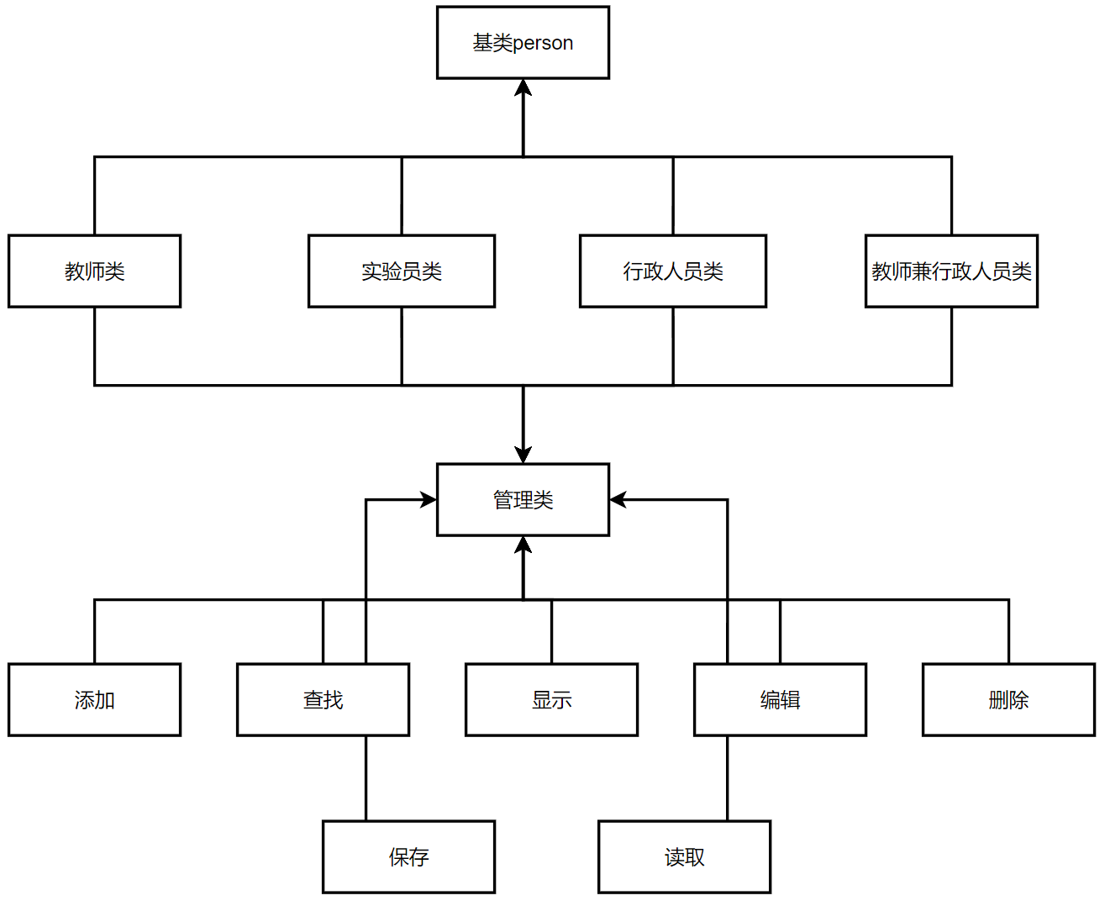

## 2.3 数据结构

## 2.3.1类设计

1. 人员类

主要用来描述人员的基本信息，编号，姓名，性别，年龄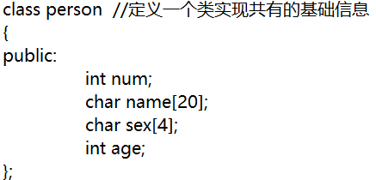

1. 教师类

教师类除基本信息外，还包含所在系，专业与职称，录入信息与输出信息

1. 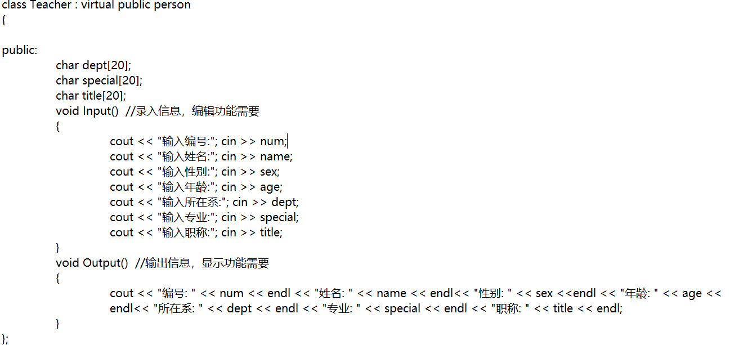实验员类

实验员类除基本信息外，还包含实验室和职务，录入信息和输出信息

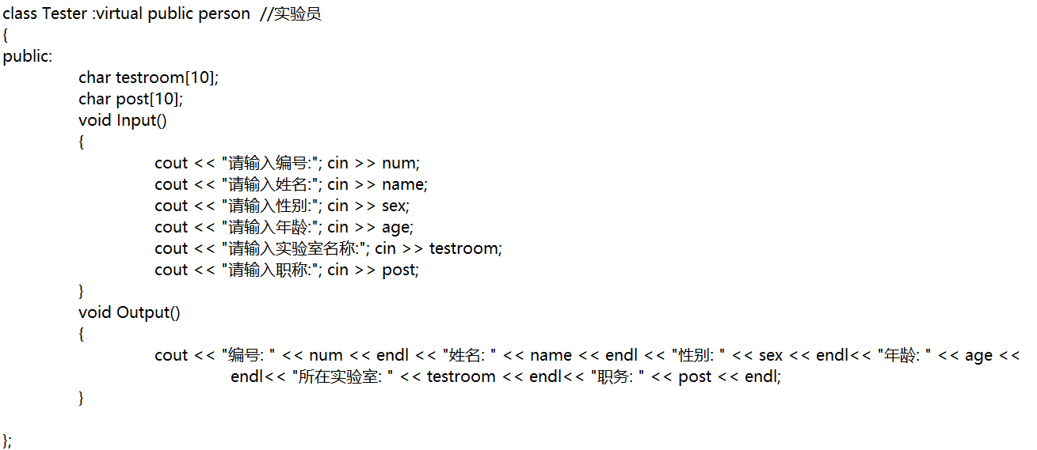行政人员类除基本信息外还应包含政治面貌，职务，输入信息和输出信息

1. 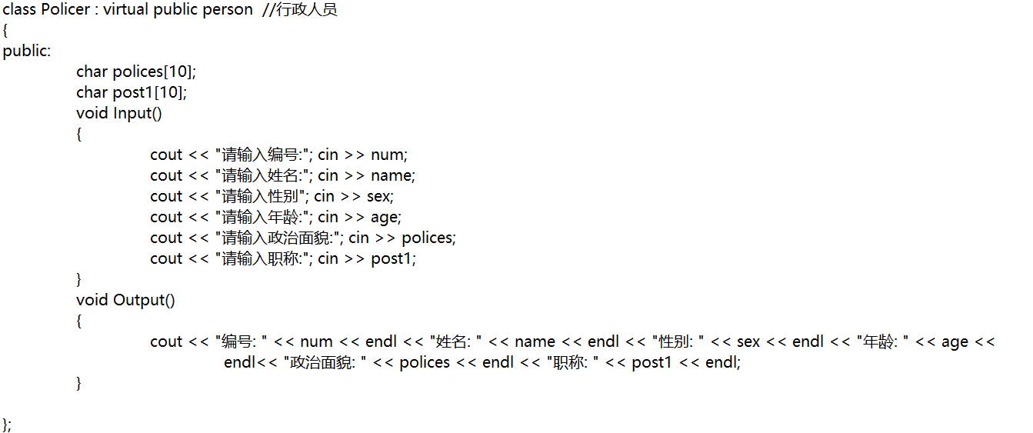教师兼行政类

教师兼行政类除基本信息外，还继承老师和行政人员类

1. 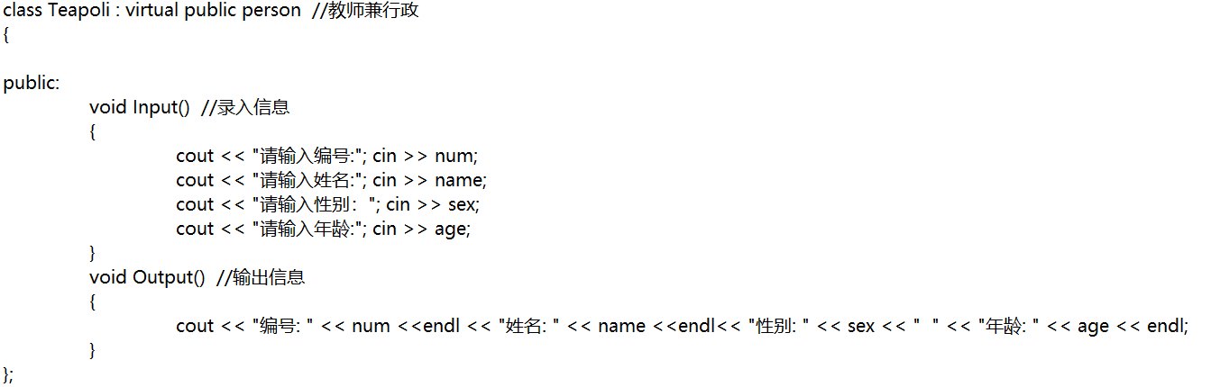管理类的设计

各派生类都有相应的管理类，管理类中包含添加函数、查询函数、显示函数、编辑函数、删除函数、统计函数、保存函数以及读取函数，

6.1教师管理类

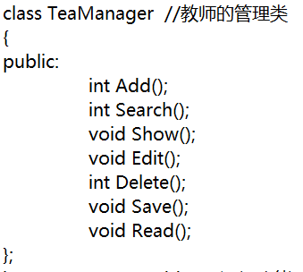

6.2实验员管理类

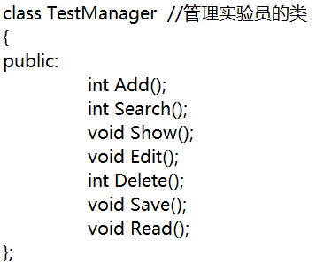

6.3行政人员管理类

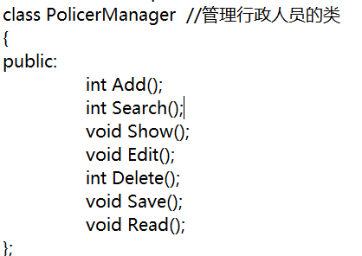

6.4教师兼行政管理类

## 

## 2.3.1函数设计

1. 教师管理类：

1.1添加函数

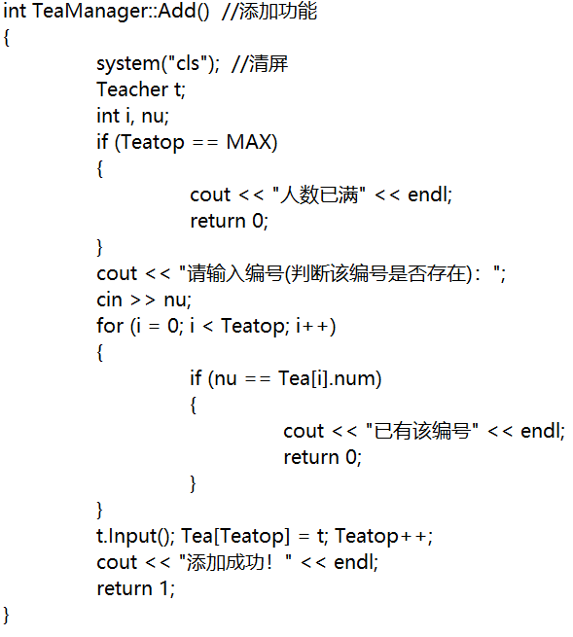

1.2查询函数

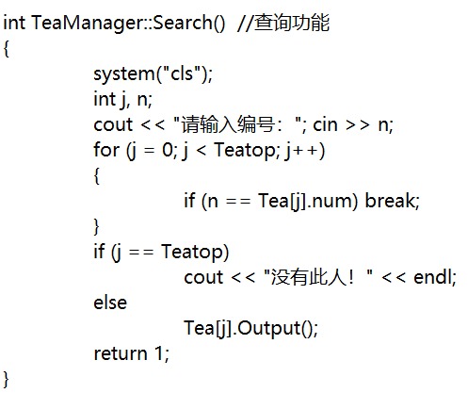

1.3显示函数

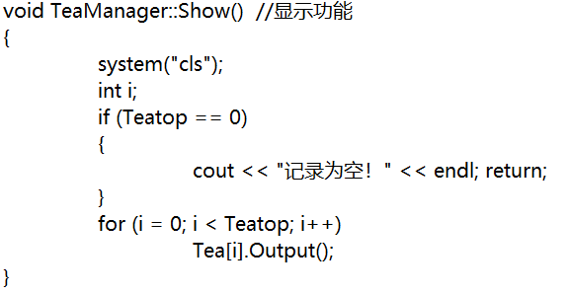

1.4编辑函数

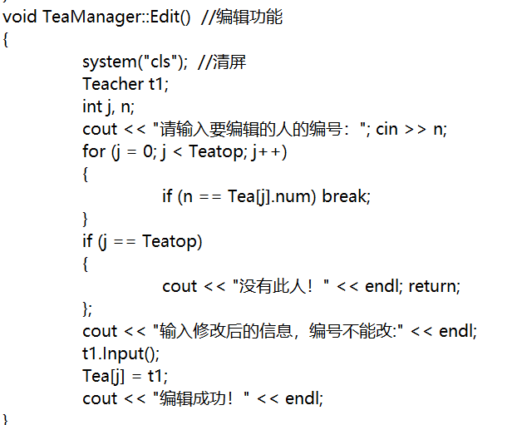

1.5删除函数

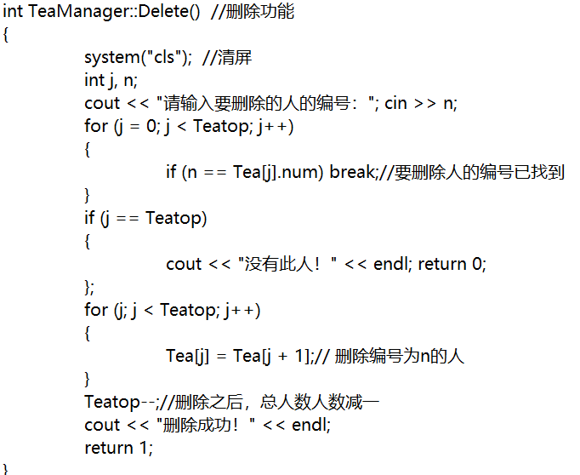

1.6保存函数

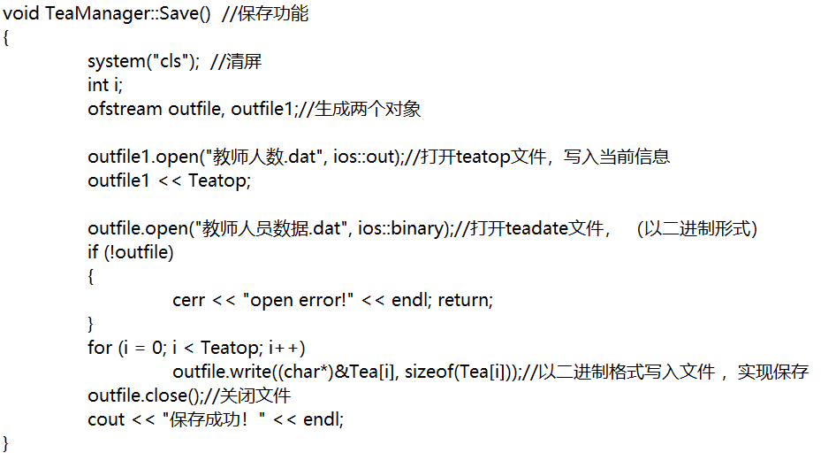1.7读取函数

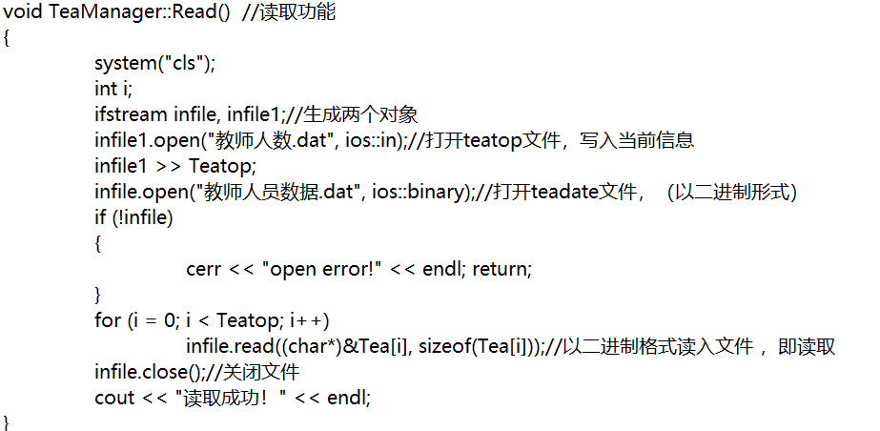1.8菜单函数

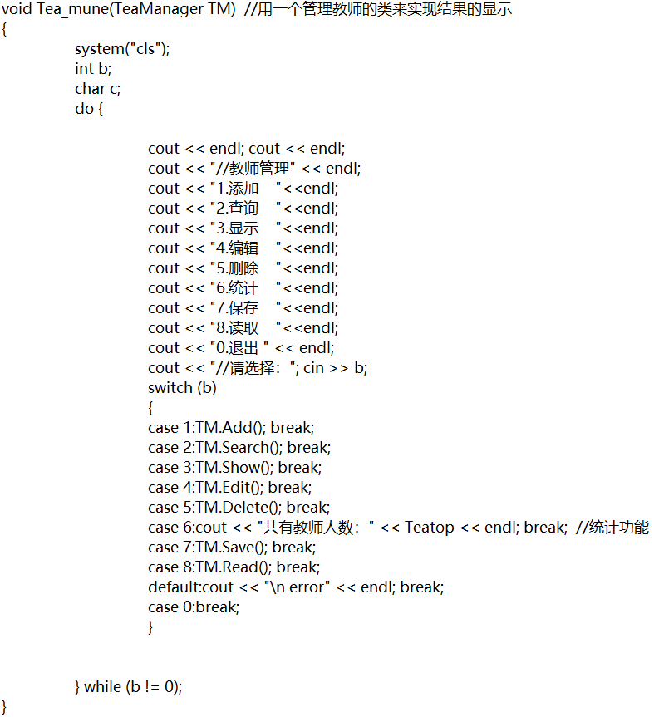

1. 实验员管理类

2.1添加函数

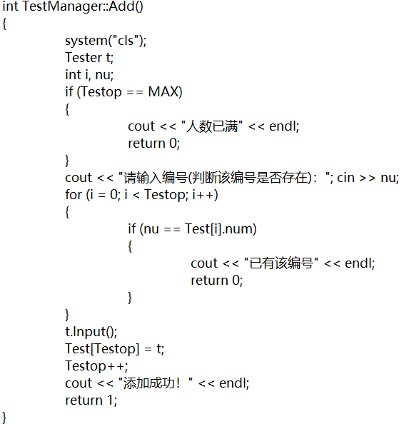

2.2查询函数

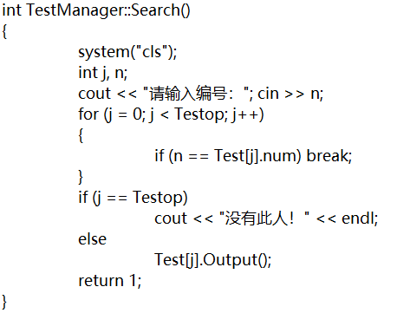

2.3显示函数

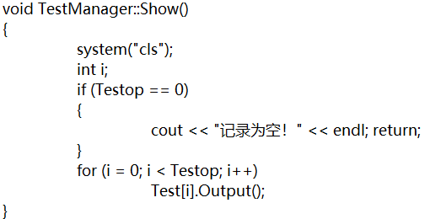

2.4编辑函数

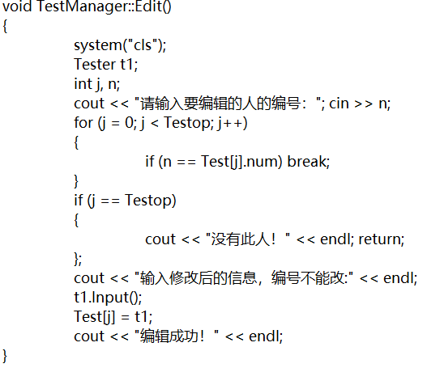

2.5删除函数

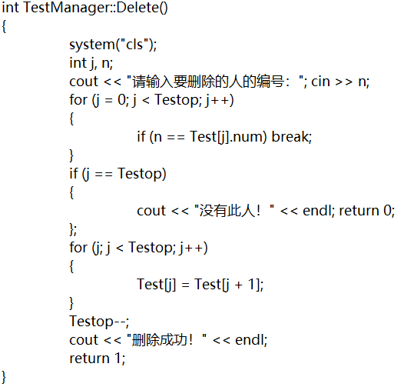

2.6保存函数

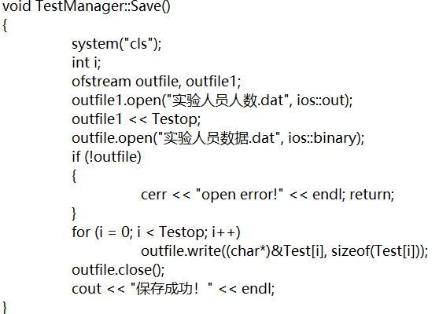

2.7读取函数

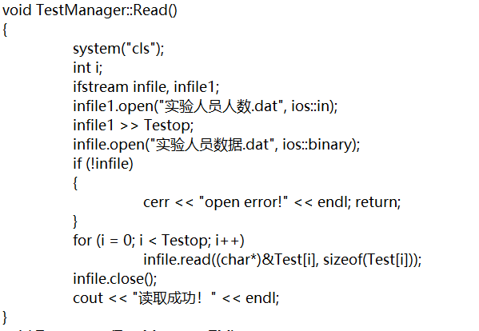

2.8菜单函数

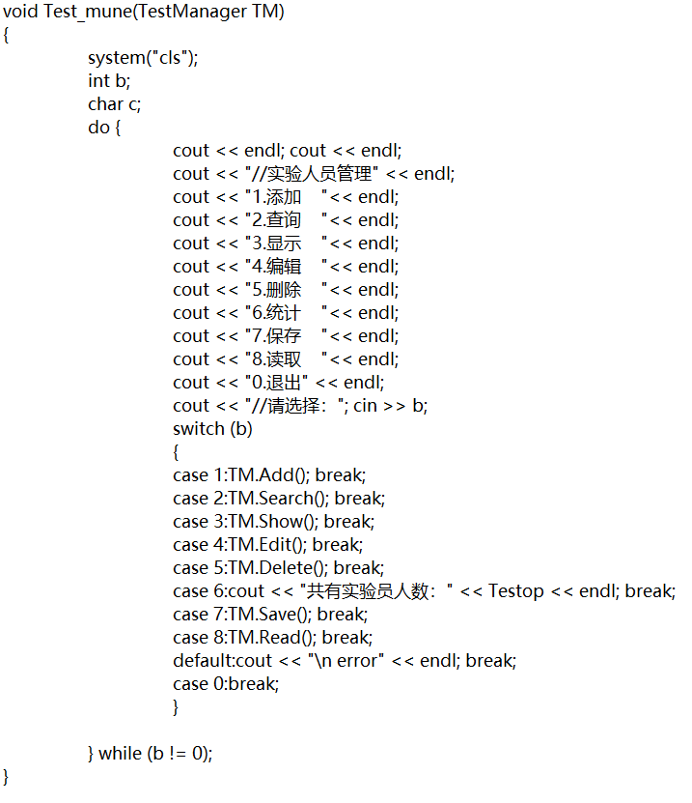行政人员管理类

3.1添加函数

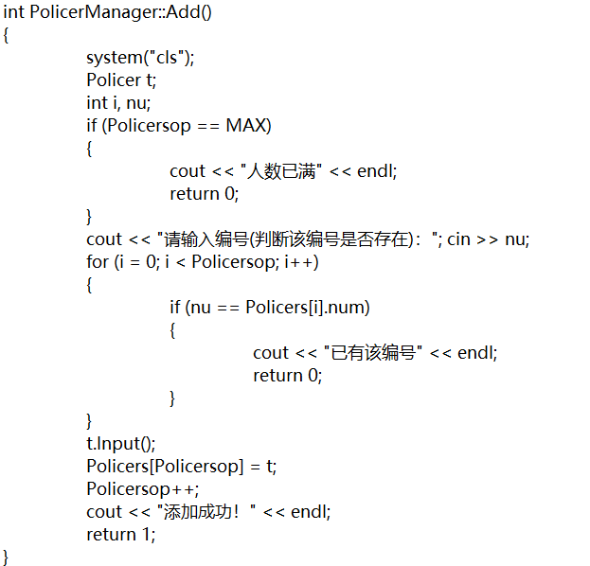

3.2查询函数

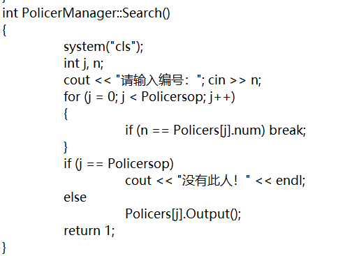

3.3显示函数

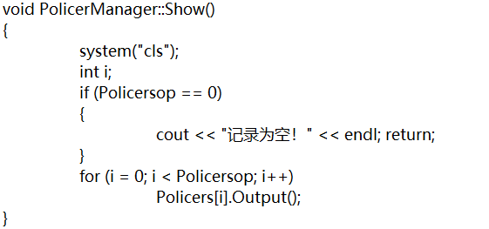

3.4编辑函数

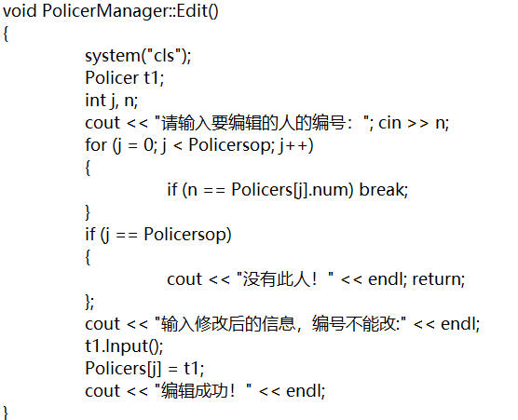

3.5删除函数

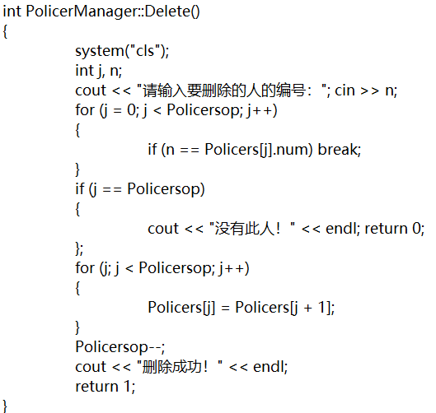

3.6保存函数

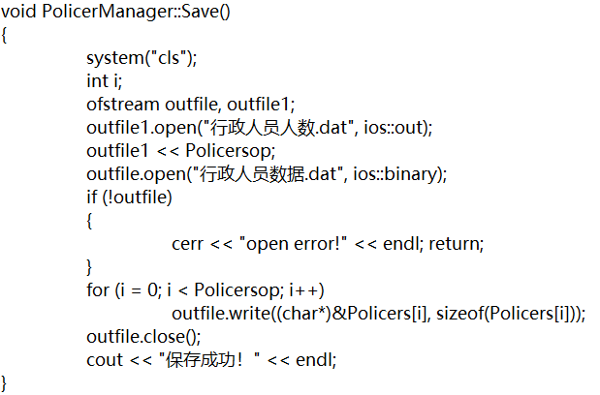

3.7读取函数

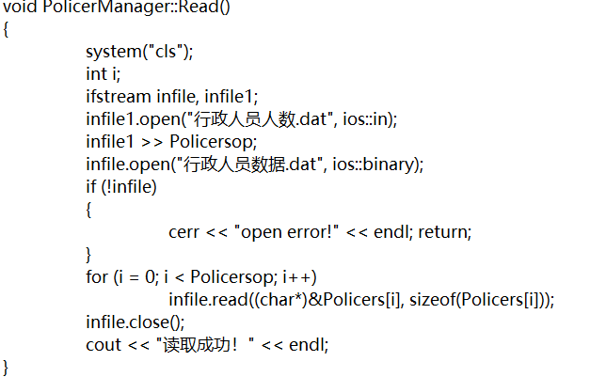

3.8菜单函数

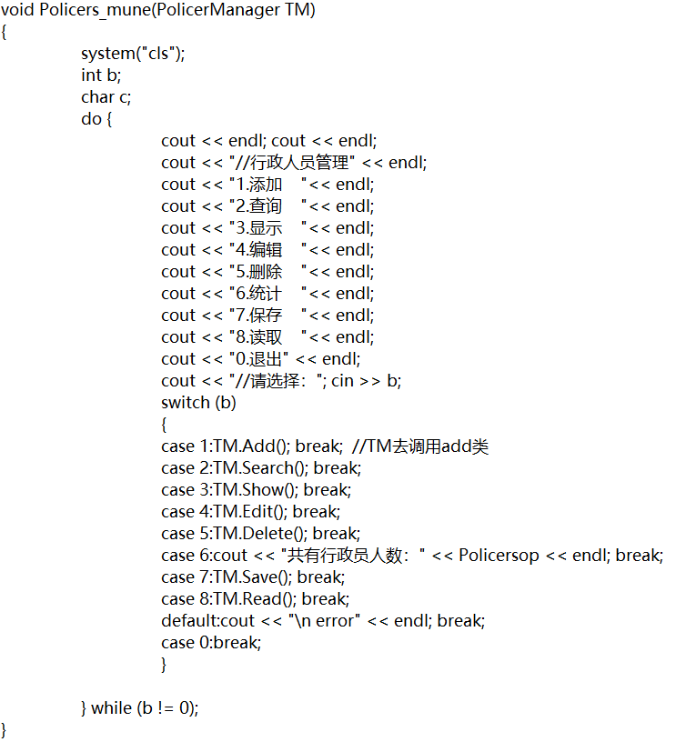教师兼行政管理类

4.1添加函数

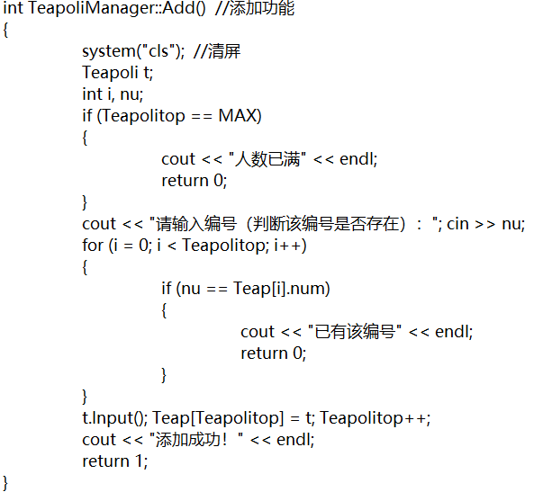

4.2查询函数

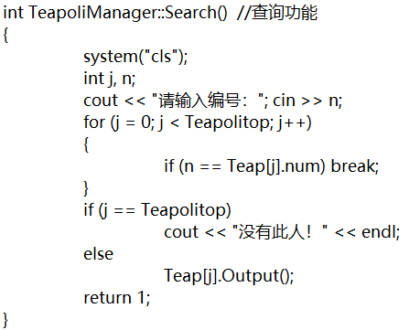

4.3显示函数

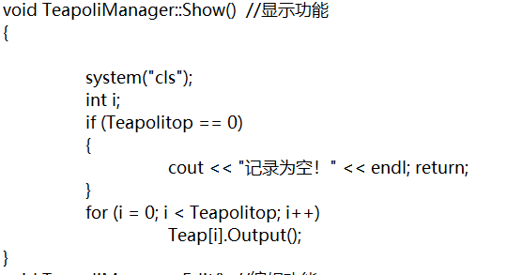

4.4编辑函数

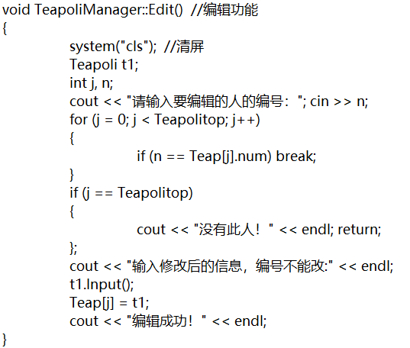

4.5删除函数

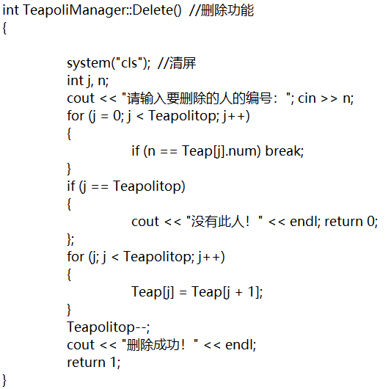

4.6保存函数

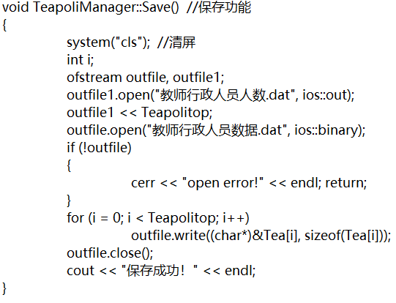

4.7读取函数

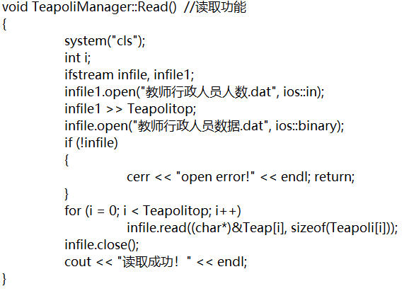

4.8菜单函数

## 2.4 设计分析和UML类图

## 2.4.1 person类

Person类负责抽象出编号，姓名，性别，年龄，作为基类派生出其他类

## 2.4.2派生类

### Teacher类，LabAssistant类，Policer类，Teapoli类都是由person通过public继承而来。由于他们各自又有属于自己的专有的数据成员，所以在继承之后还需要加入新的数据成员，并且加入了录入信息和输出信息函数。每个派生类会创建对象数组用于存放各个对象，数组初始化为设定好的最大值，并设立一个静态整型对象来记录存放对象的数量

## 2.4.3管理类

每个派生类都有对应的管理类，管理类中包含对该派生类的添加、查询、显示、编辑、删除、保存、读取功能。Teacher类的管理类为TeaManager类，LabAssistant类的管理类为LabManager类，Policer类的管理类为PolicerManager类，Teapoli类的管理类为TeapoliManager类。通过管理类可以实现数据成员与操作成员的分离

## 2.4.4添加函数

Add()函数，在函数中创建一个中间对象t，并在添加之前首先判断对象数组是否已满，未满则要求客户输入待添加的编号，利用一次循环判断是否有该编号，若无则将该编号赋值给中间对象t，由t调用录入函数，再将保存了键入的所有数据的t赋值给该派生类的对象数组，最后将计数的值++

## 2.4.5查询函数

Search()函数，本系统采用编号查找法，在函数中首先要求客户输入待查询的编号，利用一个for循环查找判断是否有相等的编号，若一直循环到计数值则输出查无此人，否则调用输出函数，输出相关信息

## 2.4.6显示函数

Show()函数，在函数中首先判断计数值是否等于0，若为0则输出记录为空，否则，利用一个for循环，调用每个对象数组的输出函数。

## 2.4.7编辑函数

Edit（）函数，本系统采用编号查找法，在函数中首先要求客户输入需编辑的编号，用一个for循环查找判断是否有相等的编号，若一直循环到计数值则输出查无此人，否则要求客户输入需更改的信息，将保存了客户键入数据的中间数组t1赋值给该派生类的对象数组。

## 2.4.8删除函数

Delete()函数，本系统采用编号查找法，在函数中首先要求客户输入需删除的编号，用一个for循环查找判断是否有相等的编号，若一直循环到计数值则输出查无此人，否则将下一个对象数组赋值给当前的对象数组，并将计数值--

## 2.4.9保存函数

Save()函数，创建两个流对象，将计数值的流对象用out方式写入，将对象数组的流对象用二进制方式写入，之所以用二进制方式写入，一是可以起到保密作用，二是可以不需重载<<符号，之后判断文件是否可以打开，若可以则通过一个for循环将对象数组一个个写入。

## 2.4.9读取函数

Read()函数，创建两个流对象，将计数值的流对象用in方式读出，将对象数组的流对象用二进制方式读出，之所以用二进制方式读出，一是可以起到保密作用，二是可以不需重载>>符号，之后判断文件是否可以打开，若可以则通过一个for循环将对象数组一个个读出。

## 2.4.10菜单函数

Menu()函数，函数输入类型为该派生类对象，在函数中利用cout输出一个菜单，1为添加，2为查询，3为显示，4为编辑，5为删除，6为统计，7为保存，8为读取，0为退出，利用switch来根据客户选择的数值再通过输入的该派生类对象来调用相应的功能。

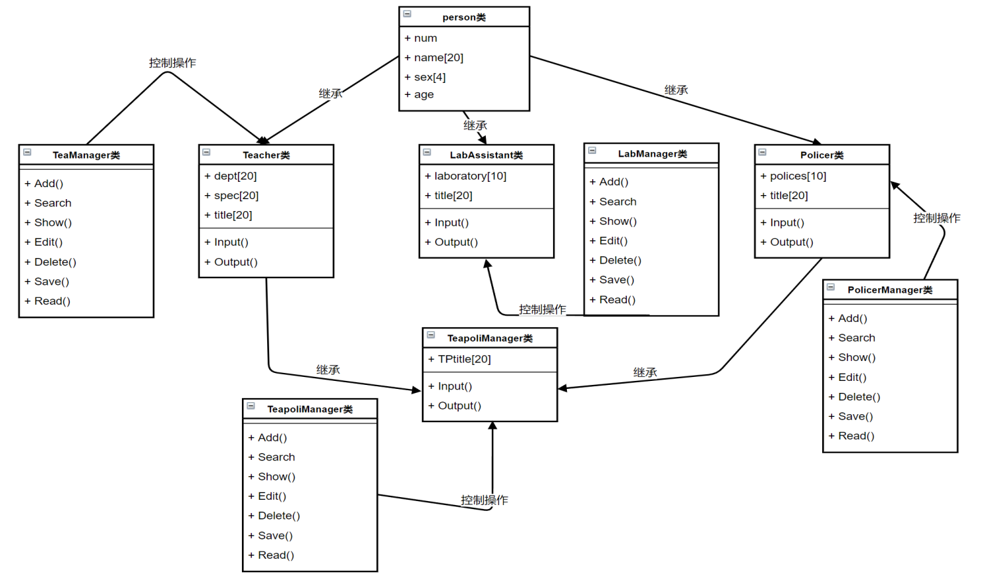

UML类图

# 3 程序调试和运行结果

## 3.1 登陆界面

高校人员管理系统登录界面如下图：

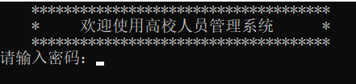

## 3.2 主界面

在登入界面输入密码后进入主界面，主界面如下图：

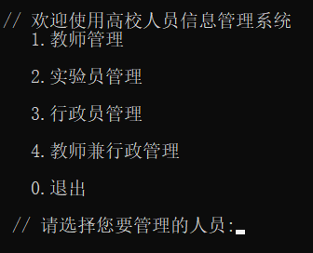

## 3.3 操作界面

在主界面选择好后，就会进入相应的管理操作界面，操作界面有添加，查询，显示，编辑，删除，统计，保存，读取与退出的功能，依次对应序号1，2，3，4，5，6，7，8，0，例如，教师管理的操作界面如下：

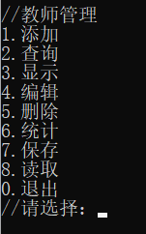

## 3.4 运行结果

在操作界面选择相应功能，根据提示操作，即可得到结果，运行结果如下：

添加操作结果

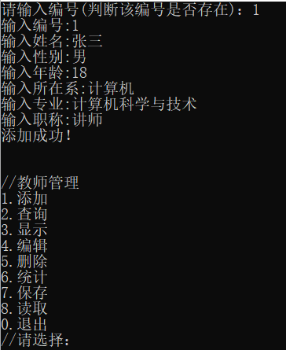

查询操作结果

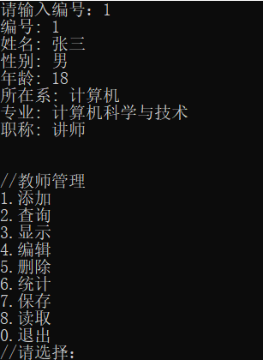

显示操作结果

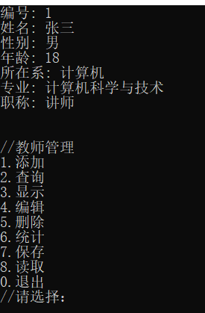

编辑操作结果

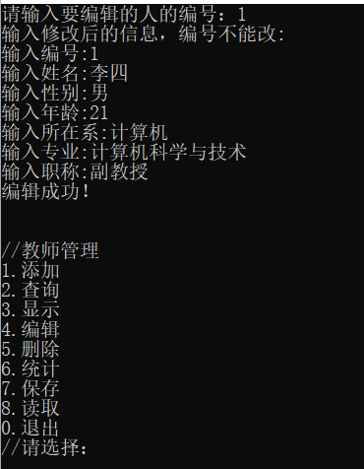

统计操作结果

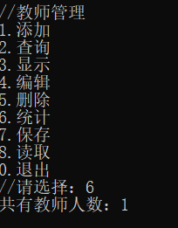

保存操作结果

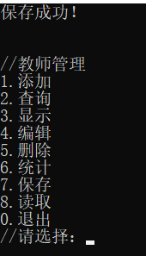

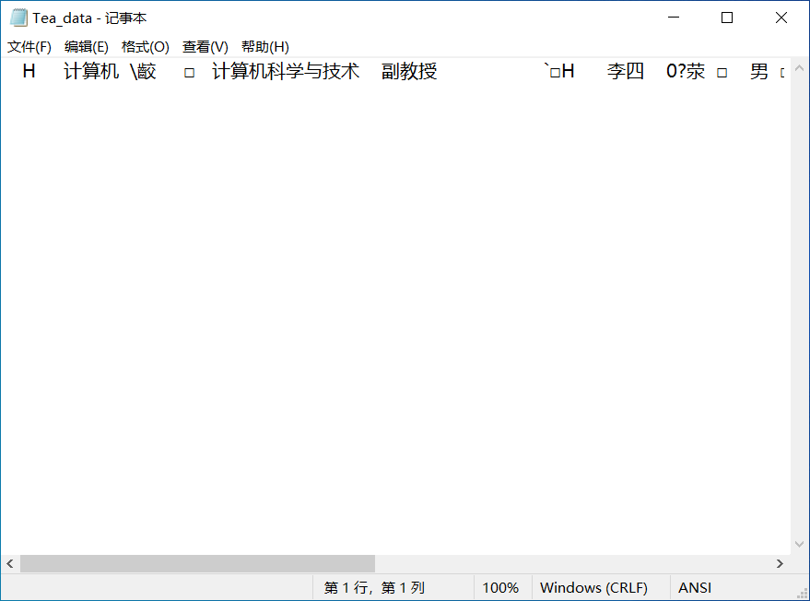

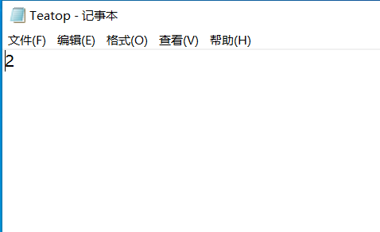

读取操作结果：

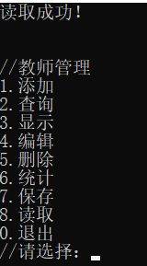

# 4 系统总结

期末的课程设计，是考察我们对本学期所学知识的掌握程度，运用综合的知识写一个综合的大程序。我们发现我有很多知识都已经忘记了，很多地方都要通过翻书对照，上网查阅相关资料才写完，通过这个课设，又使我重新掌握了很多已经忘了的和之前没掌握的的知识。设计过程中，设计基类和派生类都不算难，写他们的保存，编辑读取功能有点难度，我通过翻书，以及网上查阅相关资料解决了问题，菜单函数我一开始也不太熟悉如何去写，去实现相关的功能，后来在网上查阅了资料，通过学习别人的菜单函数来实现自己的菜单函数。在整个设计中我懂得了许多东西，树立了对自己工作能力的信心，相信会对今后的学习工作生活有非常重要的影响，而且大大提高了动手的能力，使我们充分体会到了在创造过程中探索的艰难和成功的喜悦，虽然我们的设计可能做的不太好，但是在设计过程中所学到的东西，是这次课程设计的最大收获和财富。